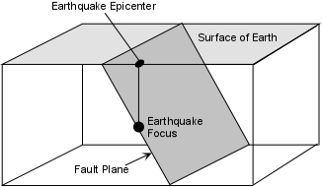
‘IT’S NOT YOUR FAULT!!’

A fault is a fracture or zone of fractures between two blocks of rock. Blocks move relative to each other along the fault plane. This movement may occur rapidly, in the form of an earthquake or may occur slowly, in the form of creep. Faults may range in length from a few millimeters to thousands of kilometers. Most faults produce repeated displacements (movement) over geologic time. During an earthquake, the rock on one side of the fault suddenly moves with respect to the other. The fault surface can be horizontal, vertical or oblique (horizontal and vertical displacement).

Strike-Slip Faults

Strike-slip faults develop when rocks are subjected to shear stress. In strike-slip faults, the movement is purely horizontal, with no up-and-down displacement. We classify strike-slip faults as either right lateral or left lateral. Imagine yourself standing on one side of a strike-slip fault, so that you are facing the fault. If the block on the other side is displaced to your right, the fault is a right lateral strike-slip fault (Figure 1). If the block on the other side of the fault is displaced to your left, the fault is a left lateral strike-slip fault.

Notice that pure strike-slip faults do not produce fault scarps. There are other tell-tale changes in the landscape that signal strike-slip faulting. The zigzag effect (offset) of the creek channel is the result of movement along the fault (Figure 1). As you might guess, where the two massive blocks on either side of a strike-slip fault grind against each other, rock is weakened. Streams flowing across strike-slip faults are often diverted to flow along this weakened zone.
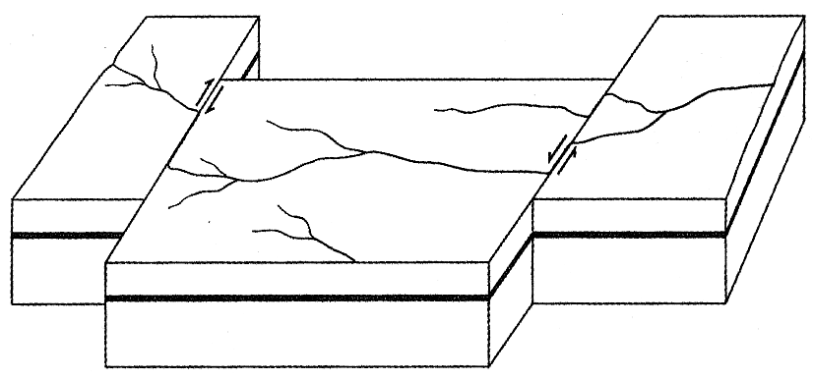
Figure 1. Right and left-lateral strike-slip faults.



Dip-Slip Faults

When distinguishing between the types of dip slip faults, we define the block of rock above the fault plane as the hanging wall block and the block of rock below the fault plane as the footwall block (Fig.2). The terms "hanging wall" and "footwall" are old mining terms. The hanging wall block was the block of rock where miners would hang their lanterns; the footwall block was where miners would walk. It is easy to determine which side of the fault is the hanging wall if you imagine a miner standing on the fault plane. The hanging wall will be the block above the miner’s head; the footwall will be the block below the miner’s feet. Strike-slip faults are vertical and thus do not have hanging walls or footwalls.
If rocks break under tensional stress, the hanging wall will move down relative to the footwall and a normal fault forms (Figure 2). In this situation, the crust actually extends and lengthens.

When rocks break under compressional stress, the hanging wall moves up relative to the footwall, and a reverse fault forms (Figure 3). In a reverse, the crust is shortened. Thrust faults (Figure 4) are simply reverse faults in which the angle formed by the fault plane and the surface is quite shallow.

Commonly, the fault plane itself can become grooved and polished as one block of rock scrapes against the other. The scratches on the fault plane surface are called slickensides. Slickensides may record the slip orientation of the fault plane, and may even feel smoother in the direction of slip.

There is another relationship between rocks on either side of the fault plane that can be used in distinguishing normal and reverse faults and are seen in Figures 2 and 3. If the rocks are right side up then the normal fault brings down younger rocks over older rocks. Under the same conditions the reverse fault moves older rocks over younger rocks.

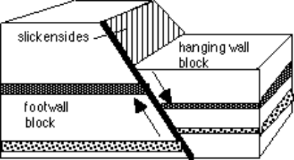
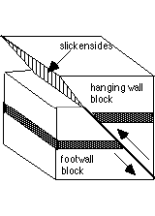
Figure 2. Normal Fault
Figure 3. Reverse Fault

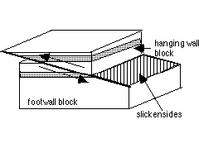
Figure 4. Thrust Fault

Model of Three Faults

Procedures

1. Color the fault model that is included according to the color key provided.
2. Cut out the fault model and fold each side down to form a box with the drawn features
on top.
3. Tape or glue the corners together. This box is a three-dimensional model of the top layers
of the Earth’s crust.
4. The dashed lines on your model represent a fault. Carefully cut along the dashed lines. You will end up with two pieces.
Types of Faults
Name:
Per: Date:

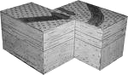
Figure 1
1. Referring to Figure 1, does it make any difference which side of the fault you stand on in naming the right-lateral or left lateral strike-slip fault? Explain.

2. Compare and contrast a reverse fault and a thrust fault.

3. Explain how slickensides are used to determine the slip orientation of the fault plane.

Model of Three Faults
Normal Fault

Locate points A and B on your model. Move point B so that it is next to Point A. Observe your model from the side (its cross-section).

Draw the normal fault as represented by the model you have just constructed.

Questions
Normal Fault
1. Which way did point B move relative to point A?

2. What happened to rock layers X, Y and Z?

3. Are the rock layers still continuous?

4. What likely happened to the road? The railroad tracks?

5. Is this type of fault caused by tension, compression or shearing?
Many normal faults are found in Nevada. This is because Nevada is located in a region called the Basin and Range Province where the lithosphere is stretching.

Explain.

6. On the drawing label the hanging wall and the footwall.
Reverse Fault

Locate points C and D on your model. Move Point C next to point D. Observe the
cross-section of your model.

Draw the reverse fault as represented by the model you have just constructed.

Questions
Reverse Fault
1. Which way did point D move relative to point C?

2. What happened to rock layers X, Y and Z?

3. Are the rock layers still continuous?

4. What likely happened to the river?

5. Is this type of fault caused by tension, compression or shearing? Explain.

6. On the drawing label the hanging wall and the footwall.

Faults are important in mineral and petroleum exploration as they may either seal and act as a barrier to fluid flow (e.g., due to smearing of mud or shale along them), or may be important conduits for the migration of petroleum or mineralizing fluids. Many mineral deposits are fault and fracture controlled. Recognition of faults is also important in hydrogeological studies as fracturing along faults may produce hard-rock aquifers.

An example of a thrust fault is the fault in which the Northridge earthquake occurred. The thrusting movement raised the mountains in the area by as much as 70 cm.

Strike-Slip Fault

Locate points F and G on your model. Move the pieces of the model so that point
F is next to point G.

Draw an overhead view of the surface as it looks after movement along the fault.

Strike-slip Questions:
1. If you were standing at point F and looking across the fault, which way did the block on the opposite side move?
Strike-slip Fault

2. What happened to rock layers X, Y, and Z?

3. Are the rock layers still continuous?

4. What likely happened to the river?

5. If the scale used in this model is 1 mm = 2 m, how many meters did the earth move when the strike-slip fault caused point F to move alongside point G?
(Show all calculations for full credit)

(Note that this scale would make an unlikely size for the railroad track!) If there were a sudden horizontal shift of this magnitude it would be about five times the shift that occurred in the 1906 San Andreas fault as a result of the San Francisco earthquake.

6. Is this type of fault caused by tension, compression or shearing? Explain.

7. Is the strike-slip fault a right or left – lateral movement? Explain.

A strike-slip fault can be described as having right or left-lateral movement. If you look directly across the fault, the direction that the opposite side moved defines whether the movement is left-lateral or right-lateral. The San Andreas Fault in California is a right-lateral strike-slip fault.

Reinforcement

1. Explain the miner's method of naming faults. Use a simple diagram showing the shaft, fault
line, hanging wall, and footwall for normal and reverse faults. How did the walls get their
names?

2. Name and describe the types of faults and folds that form in convergent margins. Use a
simple diagram to illustrate your answer.

3. Name and describe the types of faults that form in a rift valley/mid-ocean ridge. Explain why
normal faults form at divergent boundaries. Use simple diagrams to illustrate both answers.

4. Name and describe the types of faults that form along a transform boundary. Use a simple
diagram to illustrate your answer.

Extra Credit
Research and classify two of the faults below. Be sure to cite the internet URL.

- Portland Hills Fault
- Molalla Canby Fault
- Burns Fault



